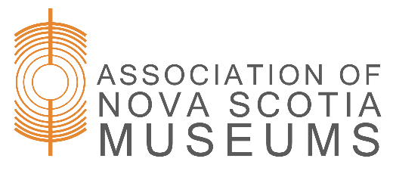
Annual General Meeting - Minutes

Friday, September 22, 2017 - 1:30pm
Best Western, Liverpool

Members in attendance: 44

- Call to Order

President, Rodney Chaisson called the meeting to order. A quorum was determined to be present.

- Approval of Agenda

Motion to approve the agenda was made by Kathy Sullivan and seconded by Louise Lindsay. Motion carried.

- Approval of AGM Minutes of May 20, 2016.

Motion to approve the minutes was made by Barb Thompson and seconded by Lisa Wolfe. Motion carried.

- Business Arising from the Minutes

There was none identified.

- Annual Reports

5.1 President’s Report

Rodney Chaisson presented his annual report with highlights of the past year’s activities and thanks to staff and board members.

Key update subjects: Museum Evaluation Program
Museum Studies Program
MuseFund
Nova Muse Updates

Rodney Chaisson moved to accept the President’s report. Louise Lindsay seconded. Motion carried.

  - Executive Director’s Report

Anita Price presented her Executive Director’s Annual Report. The report covered operations over the past year as well as highlights on the following: Evaluation of 67 Museum Sites
Training programs
Advisory Program
Engagement Map

Louise Lindsay made a motion to accept the Executive Director’s report. Lisa Wolfe seconded. Motion carried.

  - Financial Report – Audited Financial Statements

Mark Peapell presented the annual financial report, and gave an overview of the financial health of the organization. He asked if there were any questions, and there were none.

Mark moved to accept the report. Susan Clarke seconded the motion. Motion carried.

- Nominating Committee Report and Election of Officers

Katherine MacLeod, Chair of the Nominating Committee presented the report:

No nominations required as all board members have agreed to continue and there were no vacancies. Slate of board members:

Rodney Chaisson, President
Oralee O’Byrne, Vice President
Mark Peapell, Treasurer
Russell Grosse, Secretary
Judy Frotten, South West Region Director
Kathy Sullivan, Director at Large
Del Muise, Cape Breton Region Director
Marla Webber, Director at Large

Louise Lindsay moved to accept the nomination report as presented. Seconded by Kathy Holland. Motion carried.

- Appointment of Nominating Committee Chair for 2018 AGM

Judy Frotten to serve as Chair of Nomination Committee for 2018. Motion made by Kathy Sullivan, seconded by Barb Thompson. Motion carried.

- Appointment of Auditors for 2017/2018 Fiscal Year

Mark Peapell offered a motion to appoint Mitchell L. Millar, CA as auditor for 2017/2018 fiscal period. He also noted that going forward ANSM would be doing financial engagement reviews with full audits every several years. Seconded by Laurie Glenn Norris. Motion carried.

9. Muse Fund Update
Rodney and Anita provided an update on Muse Fund. Key update areas:
- Process would take about 3 years to establish
- Currently we are in a research and development stage
- Working in partnership with Community Foundations of Nova Scotia
- Update on board retreat held in September (2017)
- Support from membership to help build fund
- Fund needs to reach 2.5 million over 2 years to be sustainable

10. Adjournment

Lisa Wolfe made a motion to adjourn at 2:20 pm.

Respectfully Submitted,
Russell Grosse, ANSM Board Secretary

