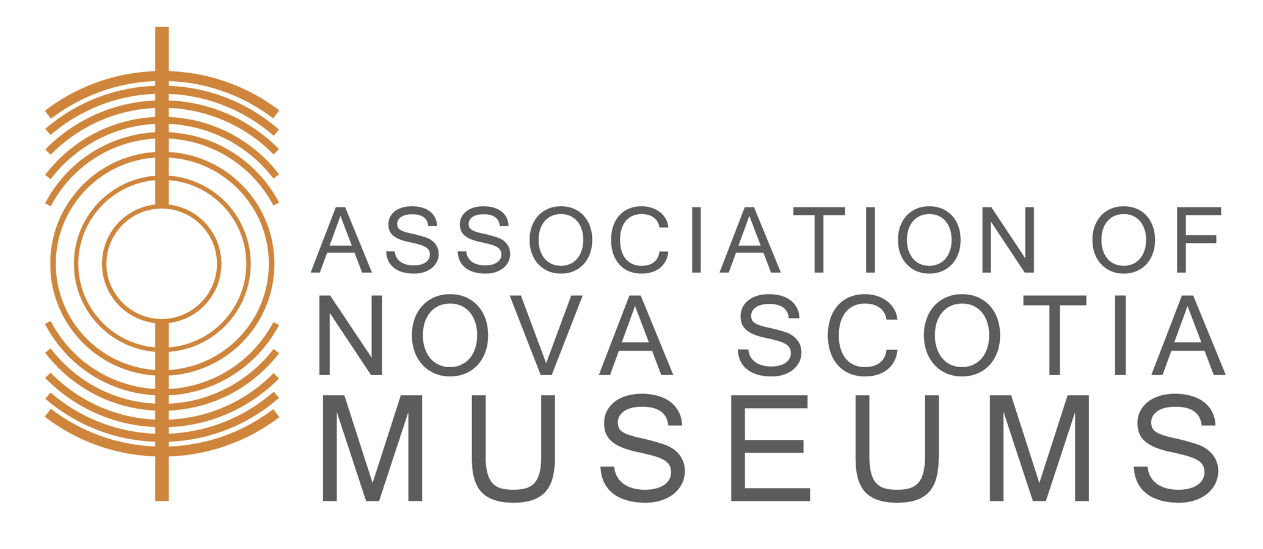

Museum Studies Program:

Museum Management & Governance

Date: November 19th – December 17th, Thursdays from 3:00PM-5:00PM
Location: Distance Format
Facilitator: Virginia Stephen
Enrolment Limits: 40 participants

Learning Outcomes

A strong governance framework is the backbone of a healthy, sustainable and forward thinking organisation. Join facilitator Virginia Stephen as she examines the structure, management and governance of museums; the roles and responsibilities of boards, staff and volunteers; and the key tools and skills needed to fulfill those roles and responsibilities.

Key content

The role of board, staff and volunteers

Defining an organisation’s mission, mandate, vision & values

Introduction to strategic planning & business planning practices

Introduction to recruiting, training, managing and retaining staff & volunteers

Legal obligations, ethical responsibilities and accountability

Budgeting, managing finances and understanding fiscal responsibility

Participants will be able to:

Define the distinct roles & duties of board, staff and volunteers

Identify and understand the importance of key management and governance tools such as budgets, strategic plans, HR policies

Apply planning, implementation and evaluation processes to fulfill a museum’s responsibilities to community and funders

Staff and board participation in this workshop is encouraged.

Facilitator Biography

Virginia Stephen has experience as a consultant, staff member and volunteer at several museums, heritage and arts organizations, including the Art Gallery of Nova Scotia. She brings deep experience in leadership, administration, governance, curatorial practice and, most of all, education and programming. She has taught museum studies, practice courses and workshops for staff and volunteers, and has previously served as an evaluator for the Alberta Museums Association Recognized Museums Program. Virginia has also served as an evaluator for the ANSM Museum Evaluation Program since 2016.

Registration Information
- ANSM Members: $100.00
- Non-Members: $150.00
- Registration Deadline: November 18, 2020 @ 5pm
Registration opens October 19, 2020 @ noon. Register online by following the links or send a completed registration form with payment by cheque to: Association of Nova Scotia Museums, 1113 Marginal Road, Halifax, Nova Scotia, B3H 4P7
If registering by mail/cheque, please notify the ANSM office in advance by phone or email.
For more information call (902) 423-4677 or email services@ansm.ns.ca

