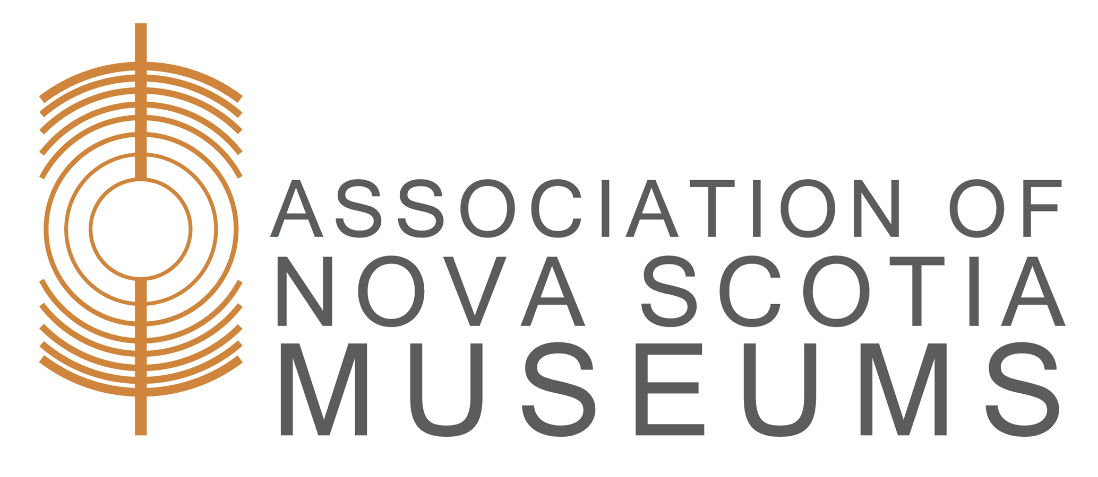

Museum Studies Program:

Museums and Communities

Date: October 8, 15, 22, 29, & November 12, 2020
Location: Distance Format
Facilitator: Dr. Candace Tangorra Metalic
Enrolment Limits: 40 participants

Learning Outcomes
Museums face many challenges and key amongst these is maintaining relevance and engaging our communities. Join Candace Matelic for a series of transformational sessions as you learn about engaging your community and the long term benefits for your museum.

- Define your community and learn how to discover what matters to it
- Learn what community engagement is and is not, and how it differs from audience development
- Discover how community engagement has initiated a journey towards relevance and sustainability for other organizations
- Understand processes to initiate, facilitate, and support community engagement, partnerships, and collaborations
- Understand why community engagement is a transformative process for museums and cultural organizations
- Assess where your organization is on its journey towards community engagement

This workshop is a must for museums wanting to forge strong and vital relationships with their communities. Museum directors, curators and board members will learn important new skills and approaches for engaging their communities. Staff and board participation in this workshop is encouraged.

This workshop can be taken as part of the ANSM Museum Studies Program or on its own.

Registration Information
- ANSM Members: $100.00
- Non-Members: $150.00
- Registration Deadline: October 7, 2020
Registration opening will be announced on Facebook, in the Beacon, and in the Events section of the ANSM website. To register, send a completed registration form with payment by cheque or money order to: Association of Nova Scotia Museums, 1113 Marginal Road, Halifax, Nova Scotia, B3H 4P7
For more information call (902) 423-4677 or email services@ansm.ns.ca

