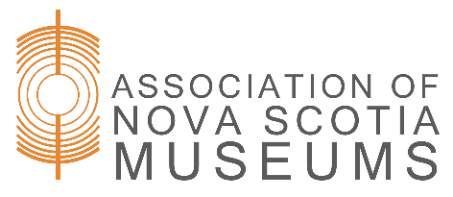
TRACK
Peer Coaching Application

The goal of the TRACK program is to build capacity in Nova Scotia’s museums through Training, Resources, Assessment, Coaching, and Knowledge-Sharing. As part of the assessment process, ANSM is seeking volunteers to review and provide feedback on either Financial Stability or Management practices. Specifically, reviewers will give feedback on the diversity of funding sources and work planning. This is an important service to museums with very limited resources.
The Peer Coaching commitment includes reviewing responses to a single question from approximately 100 museums, providing a few sentences of feedback, and participating in a group meeting to discuss overarching trends and feedback. It is anticipated that this will require about 10-15 hours of work, and reviewers will receive a small honorarium. Review work will be spread out over the summer and early fall, with the group meeting taking place in late September.

How to Apply: Send applications to Karin Kierstead at support@ansm.ns.ca by May 15, 2026

Contact Information
Name
Organization
Mailing Address
Phone
E-Mail Address

Which pillar are you applying to review?
- Financial Stability
- Management

Which position(s) have you held in museum-related work that relate to the pillar you are applying to review?:

Which languages are you proficient in?:

Which museum(s) in Nova Scotia have you worked with or could have a conflict of interest if you reviewed and provided feedback on their operations?

Why are you interested in volunteering as a peer coach?

Mindset, Skills & Experiences

Please tell us your thoughts on the following areas:

How do you keep up-to-date with current professional trends? Include how you apply this to your current work or, if retired, how you stay connected to the heritage sector.

What does teamwork mean to you? How do you work in a team environment?
This position involves giving feedback to museums. How would you approach this?

Please attach a current cv or provide an overview of your relevant training and/or experience, highlighting your knowledge of Financial Stability or Management standards of practice. Non-profit and/or museum experience are significant assets but not requirements.

