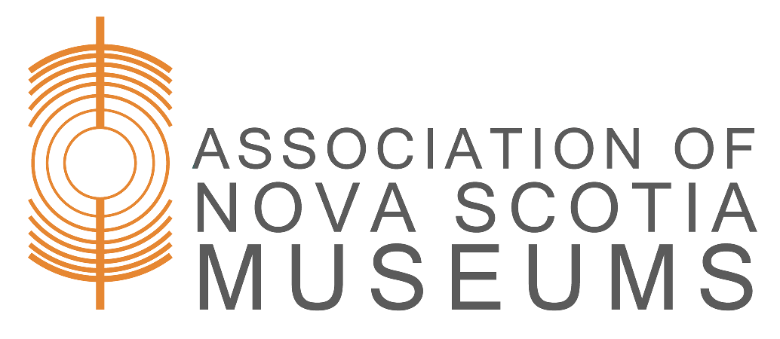

Temporary Receipt

This is to record that I have brought to the Museum the item(s) listed below for the following reason:
□ Gift □ Loan □ Sale □ Duplication
□ Identification □ Study/Examination □ Other:

Description of Item(s):

- The Museum will make every effort to ensure the care and safety of the item(s) while under the care of the [Name of Museum].
- If item(s) is/are being offered for donation:
  - The [Name of Museum] agrees to notify the owner of the above described property of the decision concerning the item(s) within 60 days of the above date. Notice will be given by phone and email, or if necessary by letter mail.
  - If the [Name of Museum] decides not to accept the item(s), the owner has 60 days from the date of notification to reclaim the item(s) by presenting this form.
  - If the item(s) is/are not reclaimed within the 60 day time frame, the [Name of Museum] will return the object(s) to the owner.
- It is the owner’s responsibility to notify the [Name of Museum] of any change in address or contact information as provided below.

Date Signature
Name (please print)
Address
Phone Email
[Name of Museum] Representative

Return: I acknowledge the return of the above in satisfactory condition
Date Signature ______
[Name of Museum] Representative

