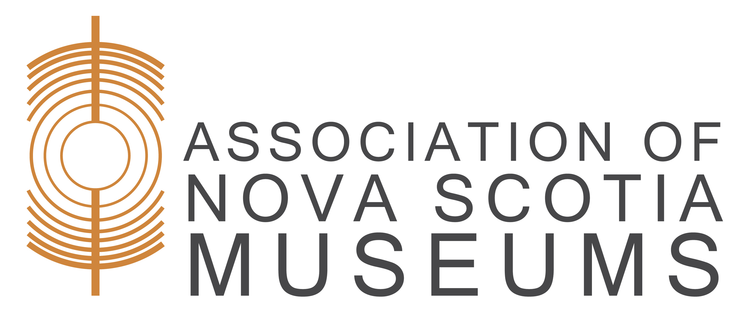

Volunteer Application

Date
Name (please print)
Address
Phone Email

Areas of Interest (check all that apply):
□ Administration □ Board of Directors □ Collections
□ Communications □ Educational Programs □ Exhibits
□ Fundraising □ Genealogy □ Grounds keeping □ Maintenance □ Marketing □ Research
□ Special Events □ Tour Guide □ Website
□ Other

Why do you want to volunteer at the museum?

Previous employment, volunteer, or educational experiences:

What is your availability?
□ Monday □ Tuesday □ Wednesday □ Thursday
□ Friday □ Saturday □ Sunday
□ Morning □ Afternoon □ Evening
□ Specific Days/Hours:

How long of a commitment are you able to make?
□ 3 months □ 6 months □ 1 year □ other

I hereby authorize the museum to maintain this information in their records, with the understanding that it will not be shared outside of the museum. Furthermore, I understand and will respect the confidential nature of information that I may access in performing my volunteer duties for the museum. I also understand that it is museum policy to request a criminal record check and that it is my responsibility to submit the check in a timely fashion.
Signature Parent/Guardian (if under 16)

