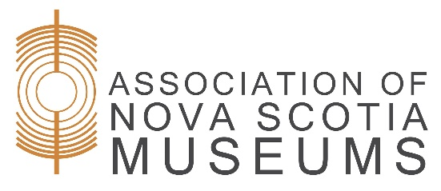
Intention to Participate
Museum Evaluation Program

- Contact Information
Name of Museum:
Governing Authority:
Operating Structure:
☐ Indigenous
☐ Government
☐ Municipal
☐ Provincial
☐ Federal
☐ Non-profit
☐ Provincially incorporated
☐ Federally incorporated
☐ Other:
Website:
Email:
Phone Number:
Mailing Address:

Please name and provide the civic addresses of all buildings that comprise the museum, are the responsibility of the governing authority, and/or are used to house the collection:
___________________________________________________________________________
___________________________________________________________________________
Primary Contact:
Position/Title: ________________________________________________________________
Phone Number (if different from museum phone number): ___________________________
Email (if different from museum email): ___________________________________________
Secondary Contact: ___________________________________________________________
Position/Title: ________________________________________________________________
Phone Number: ______________________________________________________________
Email: ______________________________________________________________________

- Eligibility Confirmation:
To participate in the Museum Evaluation Program, an organization must:
- Meet the ICOM definition of a museum and adhere to all relevant legal and ethical standards of operation, as adopted by ANSM.
- Be registered in good standing with the Registry of Joint Stock under the Societies Act of Nova Scotia, OR be a crown corporation OR First Nations governing body OR be part of a government entity.
- Be registered as a non-profit OR charitable organization under the Income Tax Act of Canada, OR be a crown corporation OR be part of a First Nations governing body OR government entity.
- Have been in operation and open to the public for the past five calendar years.
- Be open a minimum of 350 hours per year, and be open by appointment in the off-season AND/OR have a demonstrated process for responding to off-season enquiries in a timely manner.
- Own OR have a formal agreement with the owner of a collection that reflects the museum’s mission or statement of purpose.
- Participate in the Museum Evaluation every four years. Note which year you would like to begin your participation: ________.

I hereby certify that the information contained in this Intention to Participate notice, submitted to the Association of Nova Scotia Museums, is complete and accurate, and a true representation of _______________________________ (Museum Name)
In submitting this application, the museum and its governing authority:
☐ Have approved the content and submission of the museum’s Intention to Participate
☐ Understand the basic nature of the Museum Evaluation Program and what the process
involves
We understand that participation in the Museum Evaluation Program is an ongoing process, and the ___________________________ (Museum Name) will strive to uphold high standards of operation and work towards continuous improvements.
We the undersigned, have the authority to sign on behalf of this organization. At least one signee is an executive member of the board of directors (or their designate).
______________________________________________________________________________
Name Position Title Date

______________________________________________________________________________
Name Position Title Date

