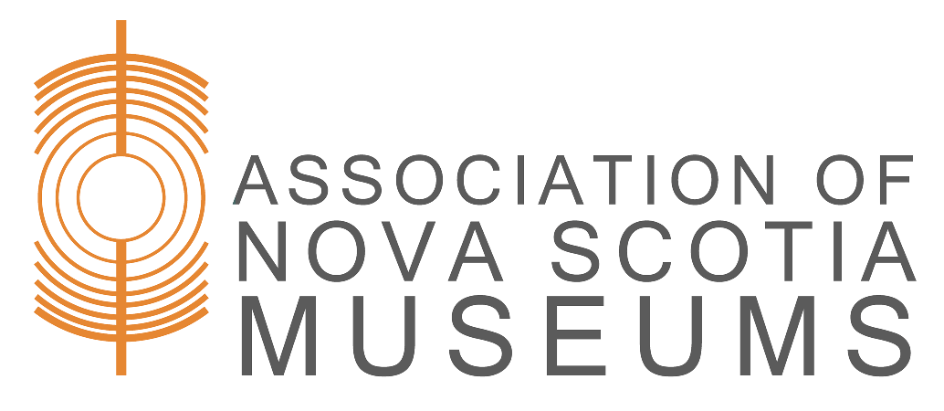
[insert your logo here]
Loan number: _______________
(office use only)

Incoming Loan Agreement

This is to certify that I, ____________________ , have loaned the object(s) listed below to the [Name of Museum], subject to the these conditions:

- The Lender is the owner of the object(s) listed below or has authority to agree and complete this contract on behalf of the owner.
- The [Name of Museum] will exercise the same precautions for loans as it does for the safekeeping and preservation of its own collection and property.
- Exhibit of the object(s) is not guaranteed.
- The [Name of Museum] may photograph or otherwise reproduce in any way the objects on loan for record or other non-commercial purposes, in compliance with applicable intellectual property laws.
- Object(s) will be returned to the lender or their duly authorized agent at the end of the loan period by presentation of this agreement. Written request and presentation of this agreement can be made for an earlier return.
- If the object(s) is/are not retrieved within 30 days of the loan period ending, the [Name of Museum] reserves the right to charge storage fees for the object(s).

Loan period: ____________________ to ____________________

Purpose of loan:
- Exhibition | - Research | - Other: ____________

Object Description(s) | Estimated value ($)

Restrictions
Credit line (i.e., how the lender should be credited)

Insurance
Party responsible for coverage:
Extent of coverage:

Lender information
Name:
Institution (if applicable):
Address line 1:
Address line 2:
City:
Province: | Postal code:
Email: | Phone:
Name of Owner, if different than Lender:
Signature: | Date:

[Name of Museum] representative signature:

Return: I acknowledge the return of the above in satisfactory condition.

Lender signature: | Date:
Museum representative:

- Original – Museum
- Duplicate – Lender

