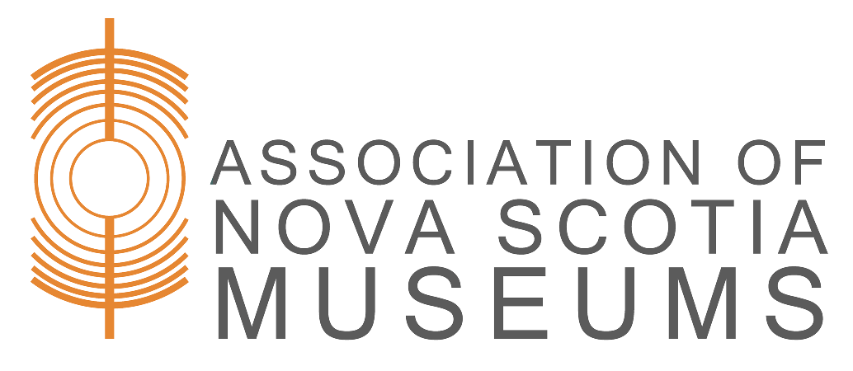

Incoming Loan Agreement

This is to certify that I, , have loaned the object(s) listed below to the [Name of Museum]. I understand that:

- The [Name of Museum] will exercise the same precautions for loans as it does for the safekeeping and preservation of its own collection and property.
- The [Name of Museum] may photograph or otherwise reproduce in any way the objects on loan for record or other non-commercial purposes, in compliance with applicable intellectual property laws.
- Object(s) will be returned to me or my duly authorized agent at the end of the loan period by presentation of this agreement. Written request and presentation of this agreement can be made for an earlier return.
- If the object(s) is/are not retrieved within 30 days of the loan period ending, the [Name of Museum] reserves the right to charge storage fees for the object(s).

Object Description(s):

Special Conditions:
Credit Line:

Insurance: [Outline which party is responsible for insurance coverage, and the extent of coverage]
Duration of Loan (one year maximum, renewable): ______________________________

Date: ____________________ Signature: ________________________________
Address:
Phone:_______________________ Email:
[Name of Museum] Representative: ______

Return: I acknowledge the return of the above in satisfactory condition
Date: _________________ Signature of Lender:
Museum Representative:
□ Original – Museum □ Duplicate – Lender

