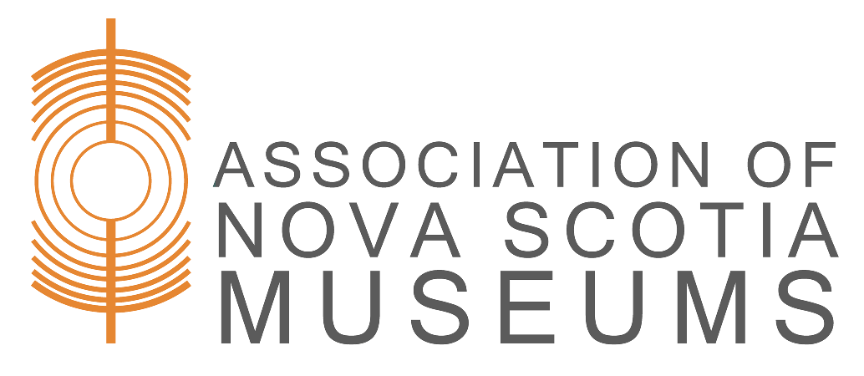

Outgoing Loan Agreement

This is to certify that I, , as a representative of _______________________ [Name of Museum/Organization] have borrowed the object(s) listed below from the [Name of Museum], subject to these conditions:

- The [Name of Museum] must be acknowledged in exhibits, publications or other media.
- Borrowed object(s) must be returned promptly at the end of the loan period.
- The _______________________ [Name of borrowing Museum/Organization] agrees to use all reasonable precautions for the safety and preservation of the object(s) listed.
Purpose of loan:

Accession number, Object name, Description, Value, Insurance: [Outline which party is responsible for insurance coverage, and the extent of coverage]

Special Conditions:

Duration of Loan (one year maximum, renewable): __________________________________

Date: ____________________ Signature: ________________________________
Address:
Phone:_______________________ Email:

[Name of Museum] Representative: ______

Return: I acknowledge the return of the above in satisfactory condition
Date: _________________ Signature of Borrower:
Received on behalf of the [Name of Museum]:
□ Original – Museum □ Duplicate – Borrower

