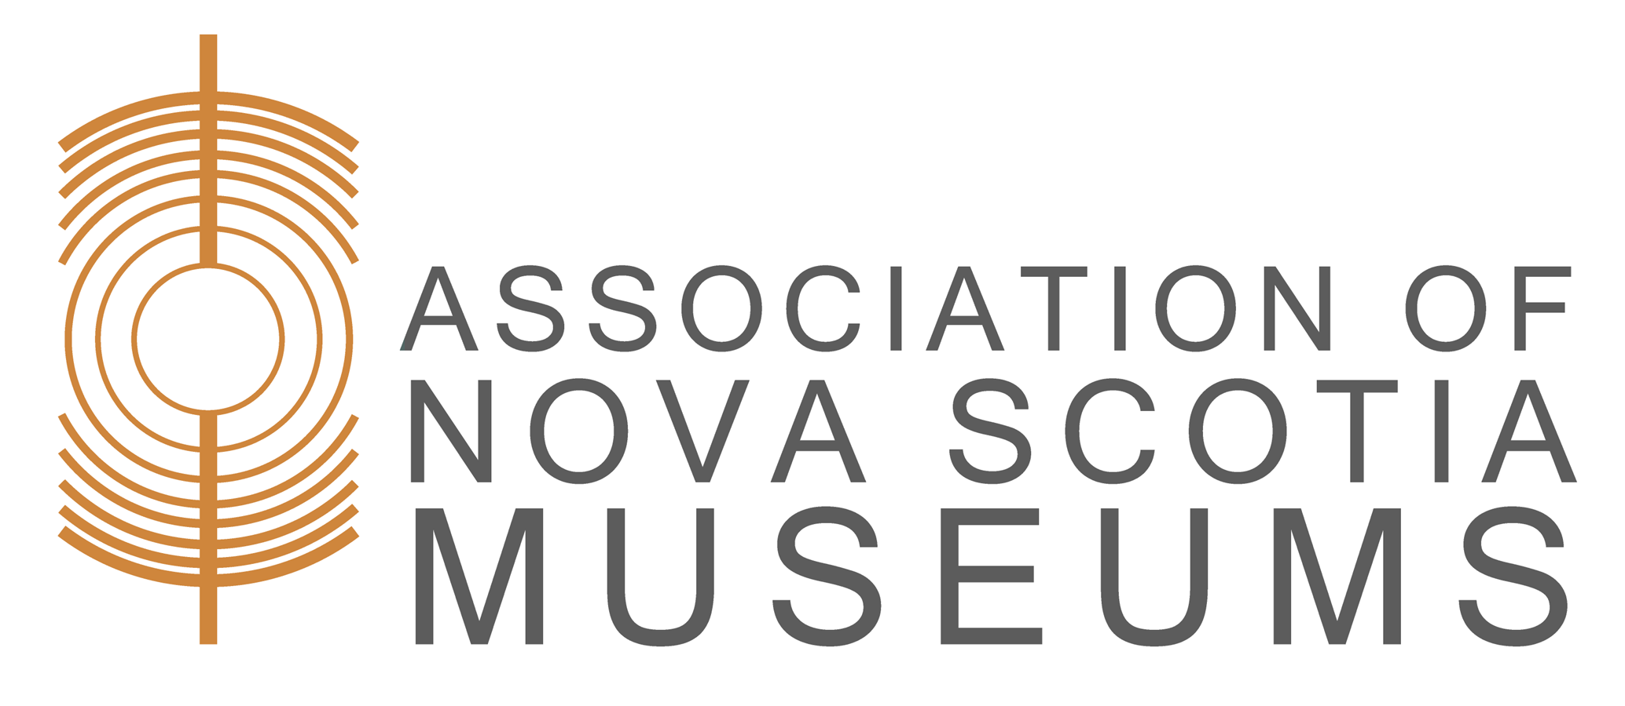

Museum Studies Program:

Museums 101

For 2023: All workshops will be offered online on Wednesdays from 2-4pm

Date: May 10, 17, 24, 31, June 7
Location: Online (Zoom)
Facilitator: Karin Kierstead, ANSM Museum Program Manager
Enrolment Limits: 30 participants

Museums 101 is the introductory module for ANSM’s courses that cover core museological functions: collections management & curatorship, interpretation, museums & community, facility management, management & governance and marketing. The Museum Studies Program is currently being updated; this is the only course offered in 2023.

Learning Outcomes
Museums 101 introduces:
- origins & evolution of museums
- ethics, guidelines & movements that guide museums
- core functions (collect, care, access)
- the new ABCs (advocacy, burnout & community-led services), trends & challenges

The course format offers a combination of lecture, group discussion and exercises. It provides an excellent opportunity for new museum board members, new staff, consultants and government staff to receive a good overview of what museums are all about and the role they play in society. It is also an opportunity for mid- and late-career professionals to learn changes in the sector.

Having worked with museums in four provinces, Karin brings a combination of education and practical experience to the workshop, providing real-world examples to the discussions and exercises. You can read her bio on the ANSM website.

This course includes an optional homework assignment. Participants receive a course certificate if the homework is successfully completed.

Registration Information
- ANSM Members: $100.00
- Non-Members: $150.00
- Registration Deadline: May 8, 2023
Registration opening will be announced on Facebook, in the Beacon, and in the Events section of the ANSM website. To register, send a completed registration form with payment by cheque or money order to: Association of Nova Scotia Museums, 1113 Marginal Road, Halifax, Nova Scotia, B3H 4P7. To register online, please follow links in the Events section.

